

**KGiSL Institute Of Technology**

**NAAN MUDHALVAN**

**Project Title:**

**Project Sales**  **Analysis**

**Team Members:**

**1.Ashika.S**

**2.Dharshana.V**

**3.Aswitha.M**

**4.Dinesh Vishnu.S**

**PROJECT OVERVIEW:**

**OBJECTIVE:**

**The project aims to analyze product sales data to derive insights using IBM Cognos, guide inventory management decisions, and enhance marketing strategies for improving sales.**

**DESIGN THINKING PROCESS:**

* **Understand**
* **Explore**
* **Ideate**
* **Prototype**
* **Test**

**DEVELOPMENT PHASES:**

1. **Data Collection and Preprocesing**
2. **Visualizations Using IBM Cognos**
3. **Insights Derivations**

**ANALYSIS OBJECTIVES AND PROCESS:**

**OBJECTIVE:**

* + - * **Identify top-selling products.**
      * **Analyze sales trends over time.**
      * **Understand customer preferences for specific products.**

**DATA COLLECTIONS:**

* **Data collected from:** [**https://www.kaggle.com/datasets/ksabishek/product-sales-data**](https://www.kaggle.com/datasets/ksabishek/product-sales-data)
* **Cleaned and preprocessed for analysis(removing duplicates)**

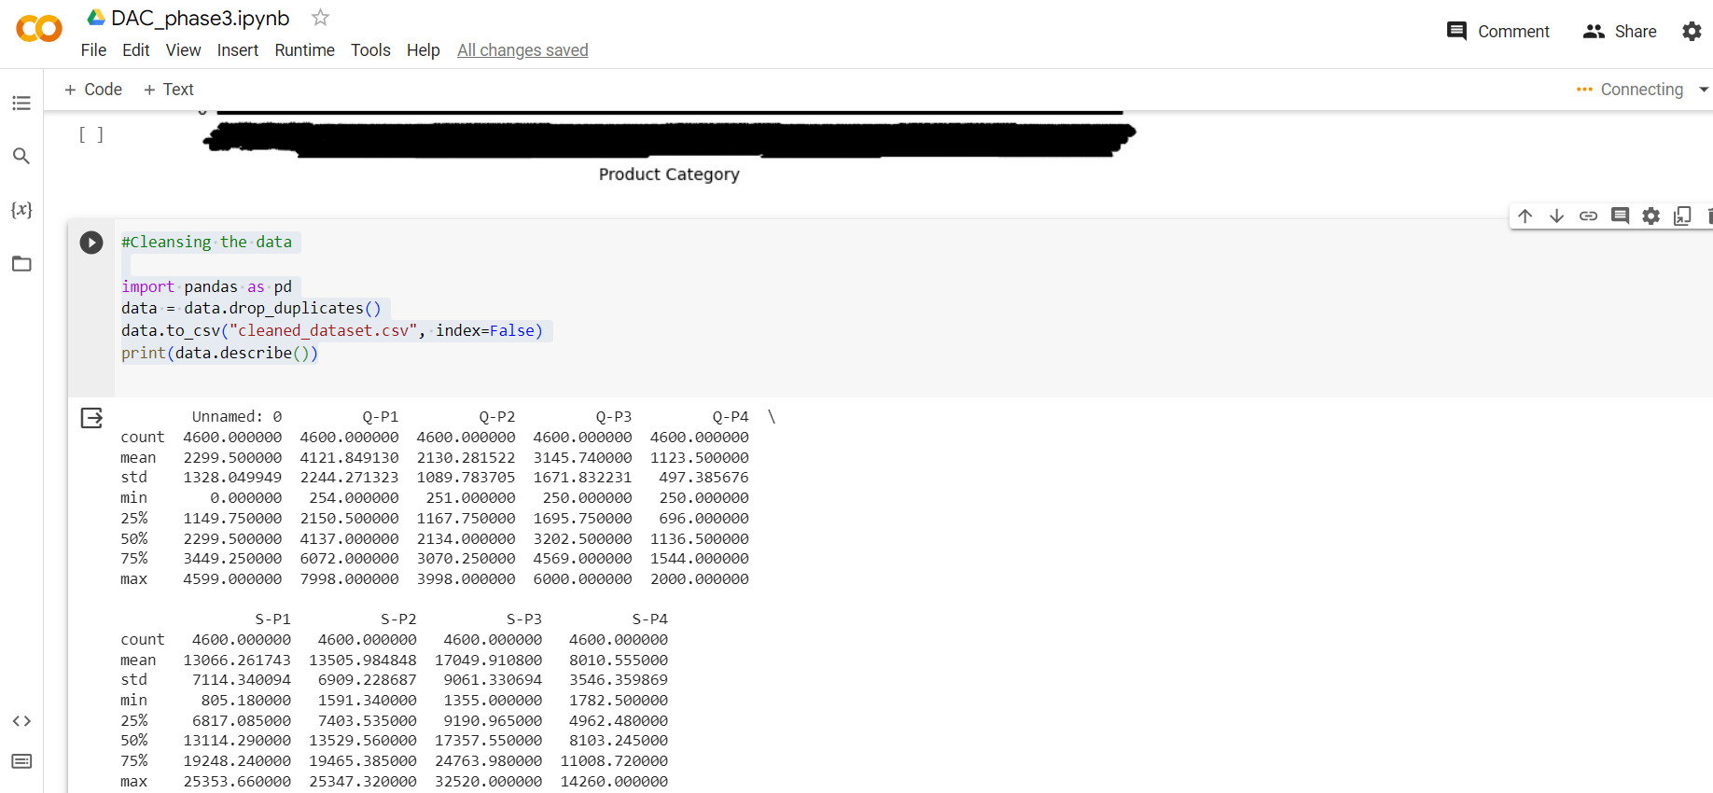

**DATA VISUALIZATION USING IBM COGNOS:**

* **Visualized top-selling products, sales trends, and customer preferences.**

**TOP-SELLING PRODUCTS**

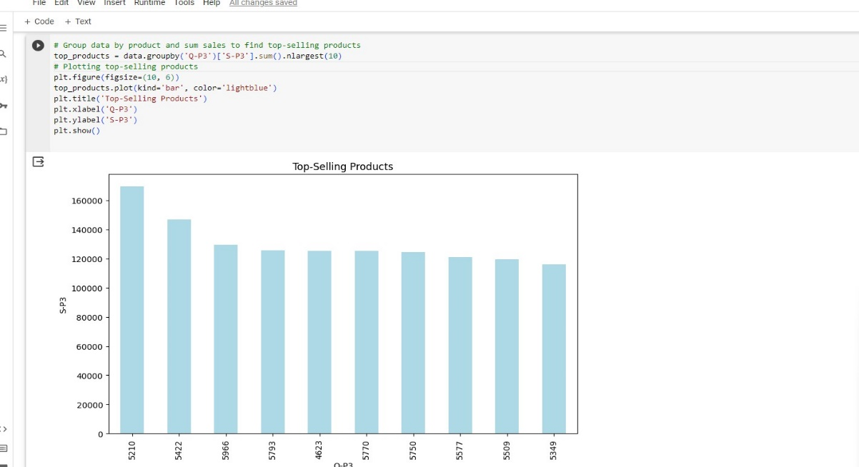

**SALES TRENDS**

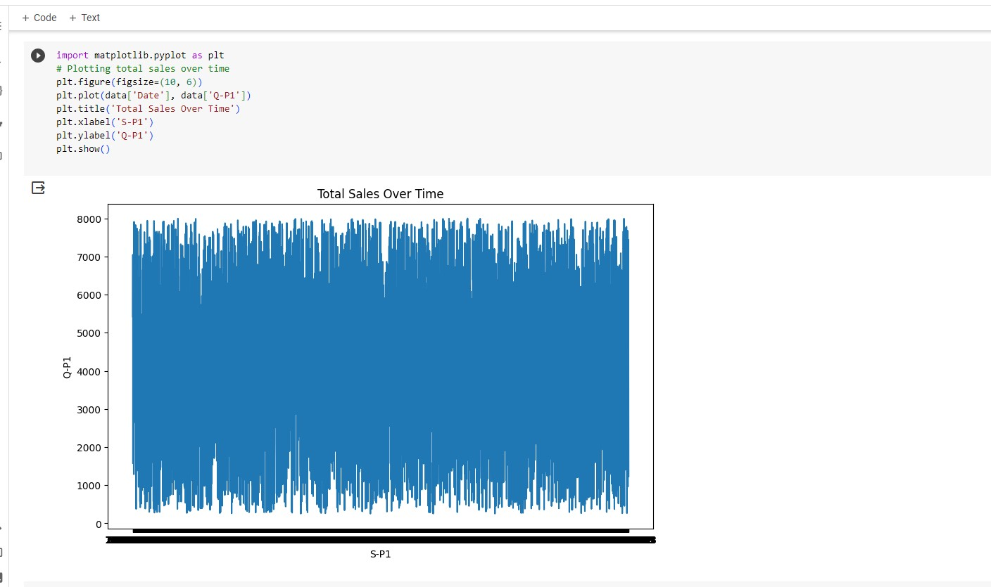

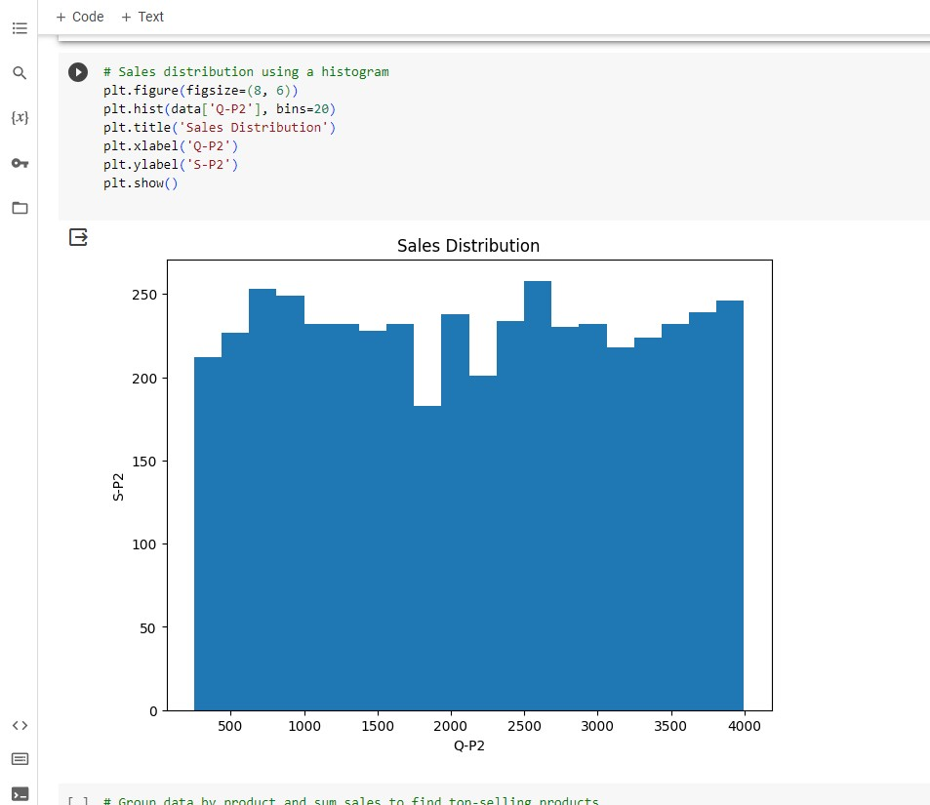

**CUSTOMER PREFERENCES**

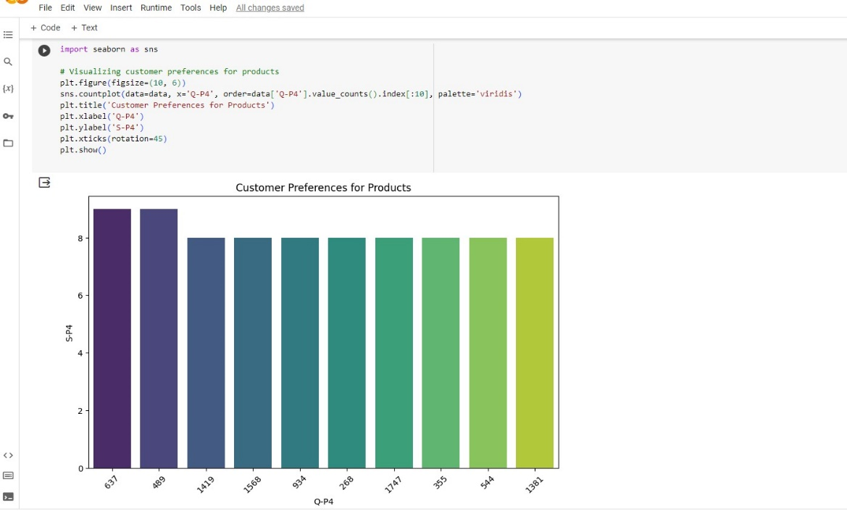

**GITUP LINK:** **https://github.com/ashika5/nm.git**

**CONCLUSION:**

**Utilizing IBM Cognos, the analysis revealed critical insights into product sales and customer behavior.**